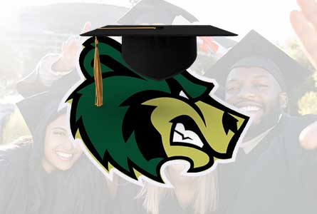

Hey CLASS OF 2024!!!!

Did you complete your FAFSA application? Do you want $100 VISA Gift Card?

Print out your FAFSA application ID number and place it in the bin in the Guidance office for a chance to win.

There will be over 100 winners chosen.

If you haven’t completed your FAFSA - There is still time

Visit to apply: https://studentaid.gov/h/apply-for-aid/fafsa

All submissions need to be in box in Guidance by May 20, 2024 for drawing at Senior Cookout

CONGRATS and GOOD LUCK!!!!

