PRINCIPALS NEWSLETTER
ACADEMIC SCHEDULE
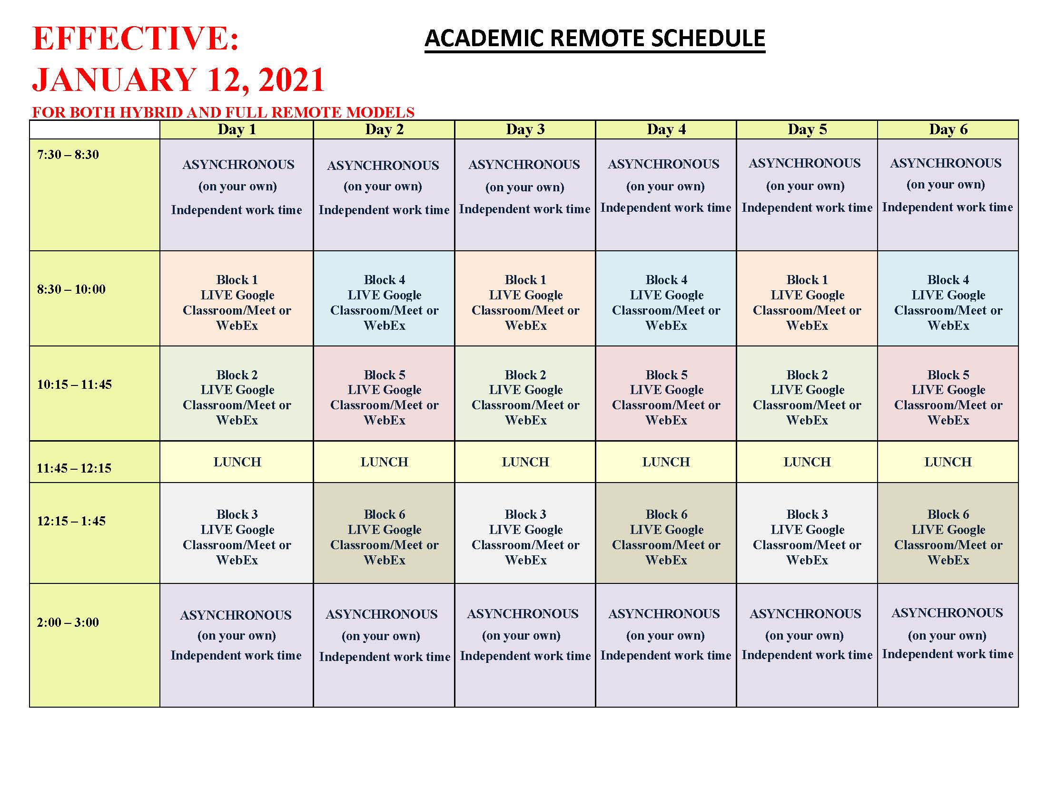
CYCLE 14 ends jan. 28  CYCLE 15 begins jan. 29  All junior and senior students are reporting to their CVTE/Shop classes in-person. Freshman and sophomore students will attend classes during their shop rotations according to the green/gold cohort model. | ACADEMIC CLASSES  CONTINUE REMOTELY  Academic classes will continue to be conducted remotely, though the schedule has been adjusted to meet the Department of Elementary & Secondary Education (DESE) adjustments to the student learning time regulations.
On behalf of Superintendent O’Brien:

Good afternoon,

I wanted to take a moment to remind you that we are following the latest CDC recommended quarantining guidelines, which state that asymptomatic individuals may leave quarantine after 10 days-provided they remain symptom free.

Academic Support  Our students will have the opportunity to attend our virtual academic support program which will run on Tuesdays and Thursdays from 3:30 p.m. to 4:30 p.m. through February 11th. These support sessions will allow students to meet with a teacher for any homework and/or tutoring assistance they may need. Please see attached flyer and should you have any questions, please email Sarah Blanchette, Academic Support Coordinator at:  sarah.blanchette@gnbvt.edu |  | 
FROM OUR NURSES’ OFFICE  Please stay home if you are sick!  We are asking our students to stay home if they are ill. This will help to minimize the incident rates of the common cold, flu and COVID-19. If your student is experiencing any of the following, please keep them home and inform the GNBVT Nurses Office at Ext. 204 or 205.  Please note:  If you should be notified that you are COVID positive or have been a close contact of a COVID positive individual, please contact your physician and notify the school nurse promptly. Our school nurses will work with you to determine dates if it is appropriate for a student to return to school. contact your physician and notify the school nurse promptly. Our School Nurses will work with you to determine dates if it is appropriate for a student to return to school. |  | Important to note:  Massachusetts Department of Public Health (DPH) has removed the requirement for the flu vaccination. While it is not required at this time, we highly recommend students get the vaccine.
VOC-TECH ATHLETICS SCHEDULE
Faculty & Staff are asked not to attend home sporting events due to SCC Rules. All games will be Live Streamed. Use the following link:

https://www.southcoastconference.org/g5-bin/client.cgi?G5button=13

Tuesday:
Varsity Girls Basketball vs. Fairhaven-6:30 p.m.
JV Boys Basketball @ Fairhaven-4:45 p.m.-Bus leaves-4:00 p.m.
Varsity Boys Basketball @ Fairhaven-6:30 p.m.- Bus leaves-5:45 p.m.
Thursday:
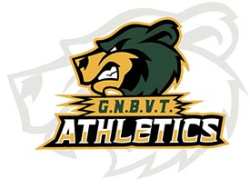
Varsity Hockey vs. Seekonk (Hetland Arena)-7:30 p.m.
Friday:
JV Girls Basketball @ ORR-4:45 p.m.- Bus leaves-3:45 p.m.
Varsity Girls Basketball @ ORR-6:30 p.m.-Bus leaves-5:30 p.m.
JV/Varsity Boys Basketball vs. ORR-4:45 p.m./6:30 p.m.
Saturday: Freshman Boys Basketball @ Bourne-10:00 a.m.-Bus leaves-8:45 a.m.
Hockey @ ORR (Gallo Arena)- 8:00 p.m.-Bus leaves-6:45 p.m.
SECURITY DEPARTMENT NEWS

In an effort to eliminate the use of tobacco and drugs being used in school, as well as incidents of violence at GNBVT, the school has installed vape detectors in many areas of the building-including bathrooms. These detectors have internal sensor technology to detect of vaping is occurring in a specific location.

The sensor can also continuously measure current sound levels and detects elevated sound, or noise anomalies, that suggest that something is amiss-such as bullying, fighting, or screaming-that should be investigated by the security department.

This technology, used with existing video monitoring systems throughout the school, will have a direct impact on expected student behavior.
ATTENTION SENIORS!!
It’s time to apply for college scholarships! Students can access the GNBVT in-house scholarships and a variety of local scholarships on our website https://www.gnbvt.edu/scholarships Scholarships are listed by the month that they are due.
Students can also access scholarship opportunities at www.studentaid.gov , www.unigo.com , www.scholarships.com Please contact your Guidance Counselor with any questions.
 | SENIOR VOC-TECH BEARS – KEEP STRONG!  All senior students and their parent/guardian were sent an email containing senior information last Friday.  In preparation for graduation, senior cap & gown measurements will take place on Thursday, January 28th (Division 1) & Friday, January 29th (Division 2).  If you have any questions, please email Mrs. McCann at dana.mccann@gnbvt.edu
STUDENT ACTIVITIES

Over 135 students signed up for virtual clubs this school year. Clubs that are currently running virtually are: After Prom, Anime Club, Bears Building Community, BPA, Gender Sexuality Alliance, Law Society Club, Non-Traditional Club, Professional Speaking Club, Rachel’s Challenge, S.A.D.D., Skills USA, Voc-Tech Theater Company, Yearbook Club & Yoga Club. If you want to sign up, please email ryan.methia@gnbvt.edu

SPIRIT DAYS
We will continue to have one themed spirit day per month throughout the rest of the school year. We will add the monthly theme and dates in this newsletter the week before.

